Programming Fundamentals Lab

## Name: Khawaja Irtaza Ahmed

## ID : F2023065202

## Section: W5

## Task: 6

### Statement:

1. Write a program for take input the list of numbers and print their squares.

### Code:

#include <iostream>

using namespace std;

int main(){

int input, square;

char control;

control = 'b';

while(control!='a')

{

cout << "\n\n\n\n\n\tEnter 'a' to end loop, enter any other character to square number : ";

cin >> control ;

if(control!='a')

{

cout << "\n\tEnter Number to be Squared : ";

cin >> input ;

square = input*input;

cout << "\n\tSquare of " << input << " = " << square ;

}

}

return 0;

}

### Output:

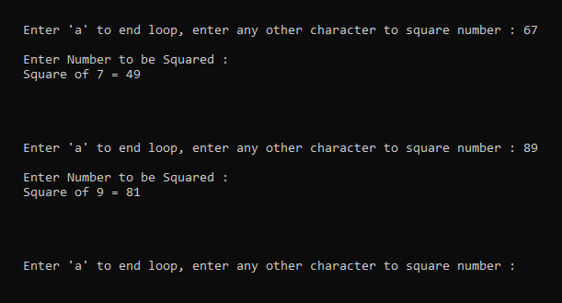

### Statement:

2. Write a program in C++ to find the factorial of a number.

### Code:

#include <iostream>

using namespace std;

int main()

{

int control, input, oginput;

cout << "\n\n\n\n\n\n\n\n\tEnter the integer of which the factorial is to be determined : ";

cin >> input;

oginput = input;

control = input;

while(control!=1)

{

control--;

input=input*control;

}

cout << "\n\tFactorial of " << oginput << " = " << input ;

return 0;

}

### Output:

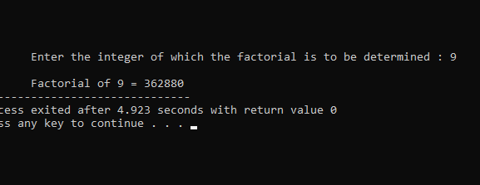

### Statement:

3. Write a program in C++ to check whether a number is prime or not.

### Code:

#include <iostream>

using namespace std;

int main()

{

int input, a, b;

cout << "\n\n\n\n\n\n\tEnter a number : ";

cin >> input;

if((input==1)||(input==0))

{

cout << "\n\t1 and 0 aren't prime nor composite.";

}

else

{

a=input;

while(a!=2)

{

a--;

b=input%a;

if(b==0)

{

cout << "\n\t" << input << " is a composite number.";

return 0;

}

}

cout << "\n\t" << input << " is a prime number.";

}

return 0;

}

### Output:

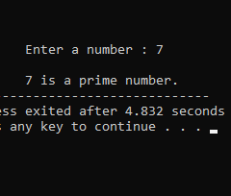

### Statement:

4. Write a program to Printing and count Even and Odd Numbers using While Loop in C++.

### Code:

#include <iostream>

using namespace std;

int main()

{

int amount, even ,odd, ogamount;

even=0;

odd=1;

cout << "\n\n\n\n\n\n\n\n\tEnter amount of even and odd numbers to print : ";

cin >> amount;

cout << "\n\n\n\tEven numbers : \n\t";

ogamount=amount;

while(amount!=0)

{

cout << even << "\n\t";

even=even+2;

amount--;

}

cout << "\n\tOdd numbers : \n\t";

amount=ogamount;

while(amount!=0)

{

cout << odd << "\n\t";

odd=odd+2;

amount--;

}

}

### Output:

